**CULTURAL AND CREATIVE ART EXAM**

**1. Define pattern________________________________________________________________**

**2. List four (4) instrument uses for folk song**

**I____________________ Ii___________________ Iii____________________**

**IV____________________**

**3. List three (3) reasons why people dance**

**I_____________________________________ Ii_____________________________________**

**Iii______________________________________**

**4. Mention four (4) dance formations**

**I________________________________ Ii______________________________**

**Iii______________________________ IV______________________________**

**5. List six (6) types of dances in our locality**

**I________________________ Ii_________________________ Iii_____________________**

**IV_______________________ V_______________________ VI_______________________**

**6. Mention four (4) main techniques for drawing**

**I______________________ Ii_____________________ Iii________________________**

**IV_____________________**

**7. List the five methods used for designing patterns on paper**

**I____________________ Ii_____________________ Iii_______________________**

**IV_____________________ V______________________**

**8. Drawing is done with _______________, _______________ and charcoal**

**9. Make patterns with different leaves**

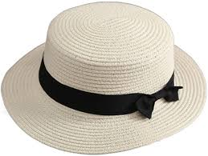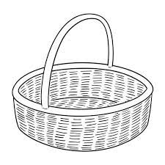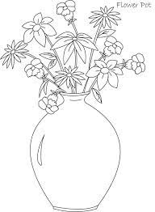**10. Colour these functional Artworks**